

Madalyn Kendrick and Michael Noseworthy

Madtown GUI Design

Slot Machine Game Design Document

Table of Contents

**Version History1**

Detailed Game Description2

Game Play Mechanics3

Controls5

Interface Sketch6

Screen Captures7

Art / Multimedia8

# Version History

* 1. Started upload of a project file
  2. Added in code that was from javascript
  3. Commented out javascript code
  4. Turned javascript code into java
  5. Added randomization code
  6. Added Interface
  7. Added reelings

## Detailed Game Description

Star Wars themed basic slot machine

### Game Play Mechanics

Start with 1000 in money, place a bet and then press Spin to move the reels. Press stop to stop the reels and if you the reels match in a certain order you will win depending on the amount placed in bet.

#### Controls

Push buttons on screen with a finger.

##### Interface Sketch

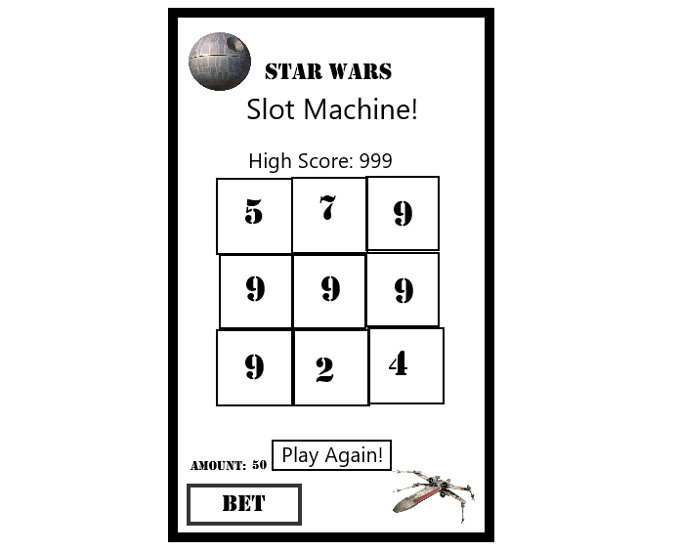

###### Screen Captures

Scoring

Gain money by placing bets and winning.

Art / Multimedia Index

